Chaturvedi, Sumeet (Cognizant)

Sumeet.chaturvedi@cognizant.com

Project manager

A Full Stack Application Case Study

Project Manager Case Study

Database Screen Shots –

Task Table –

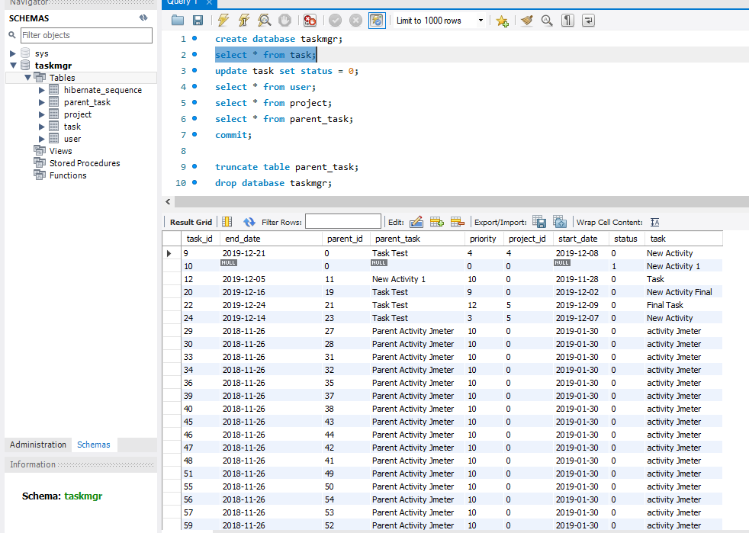

User table –

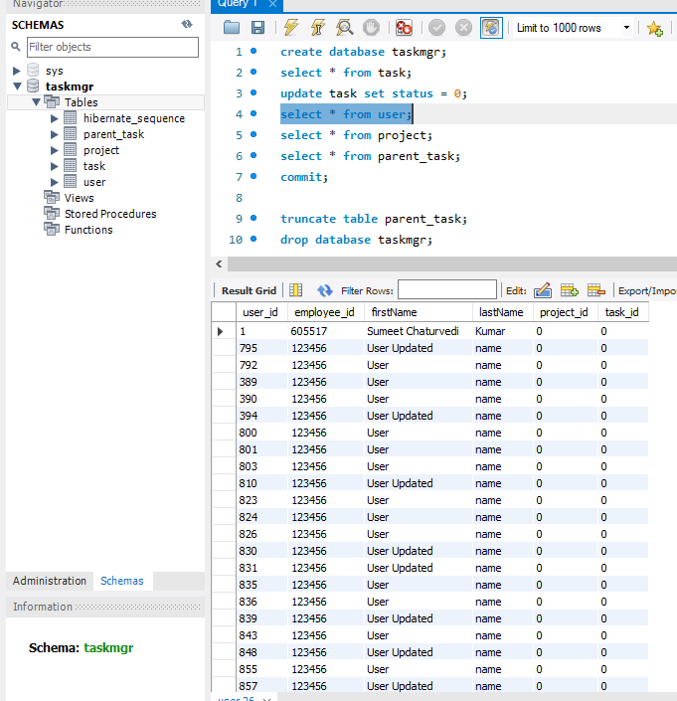

Project Table –

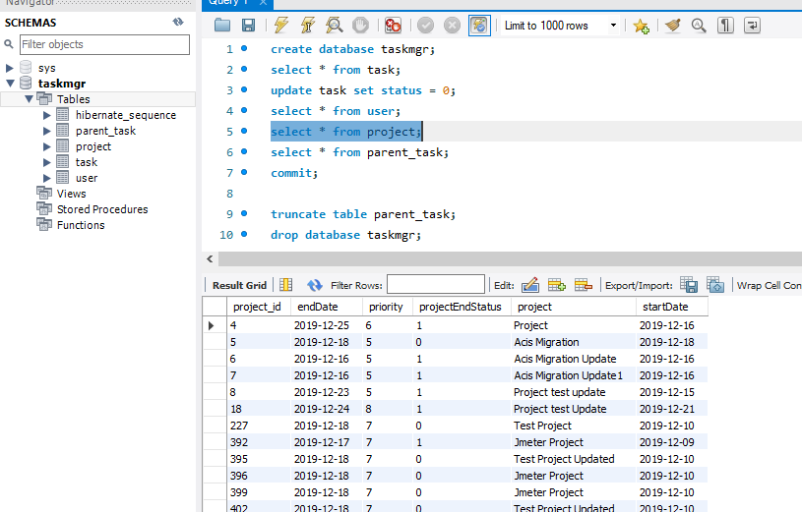

Parent Task Table –

